Login with Multirole->clickin on my orgs
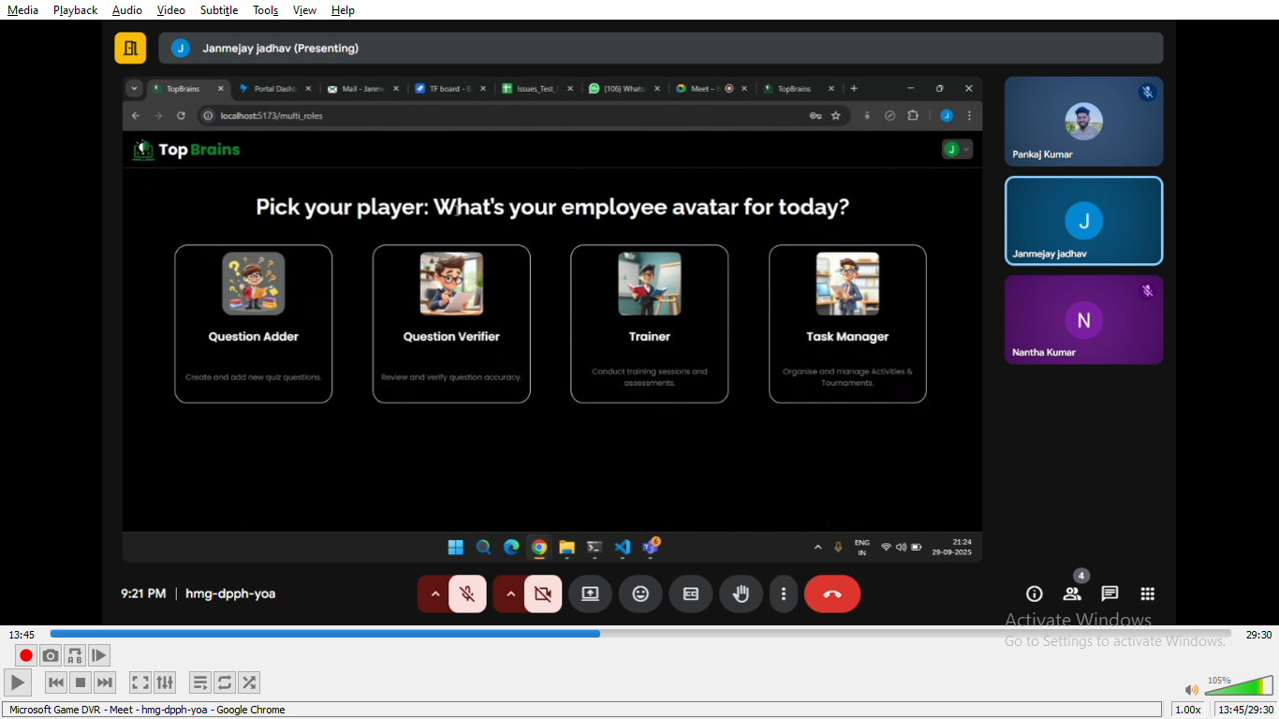

- Question adder- can create question , create assessment with the the already created question
- Question verifier
- Trainer
- Task manager

Question adder
Subject created by superadmin has shown below-> superadmin will assign 1 admin

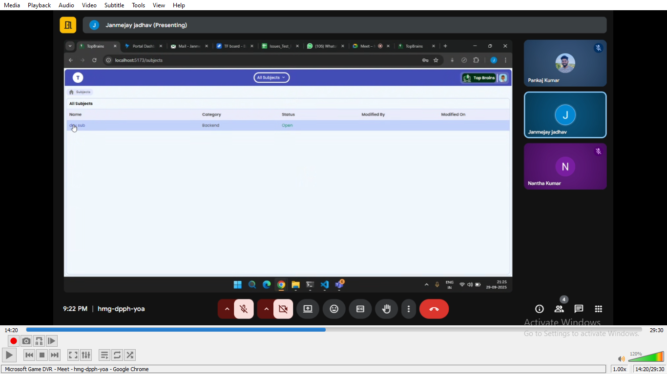
After clicking on subject (dev sub)

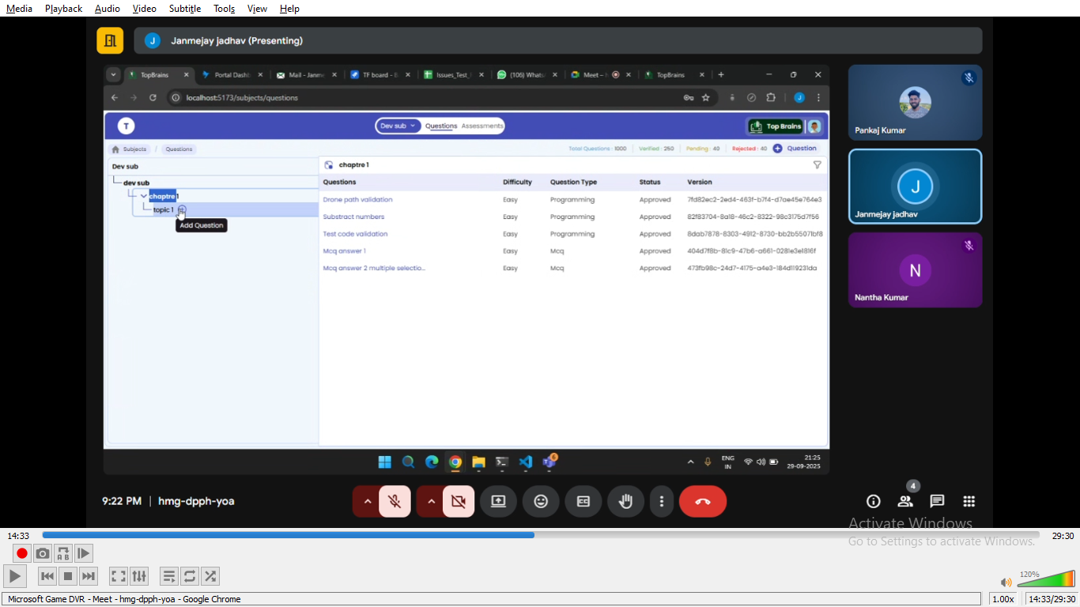

Click on create question
Elp- Entry Level Program
Qlab- a testing tool/software
Testfreshers- aptitude, coding, technica
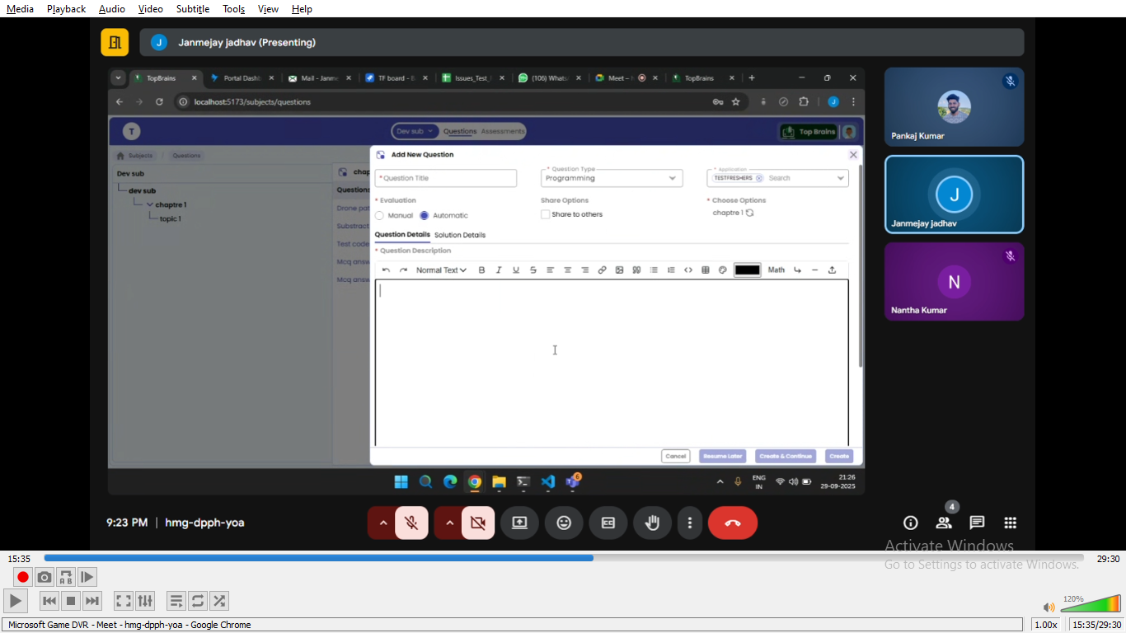
After scroll down

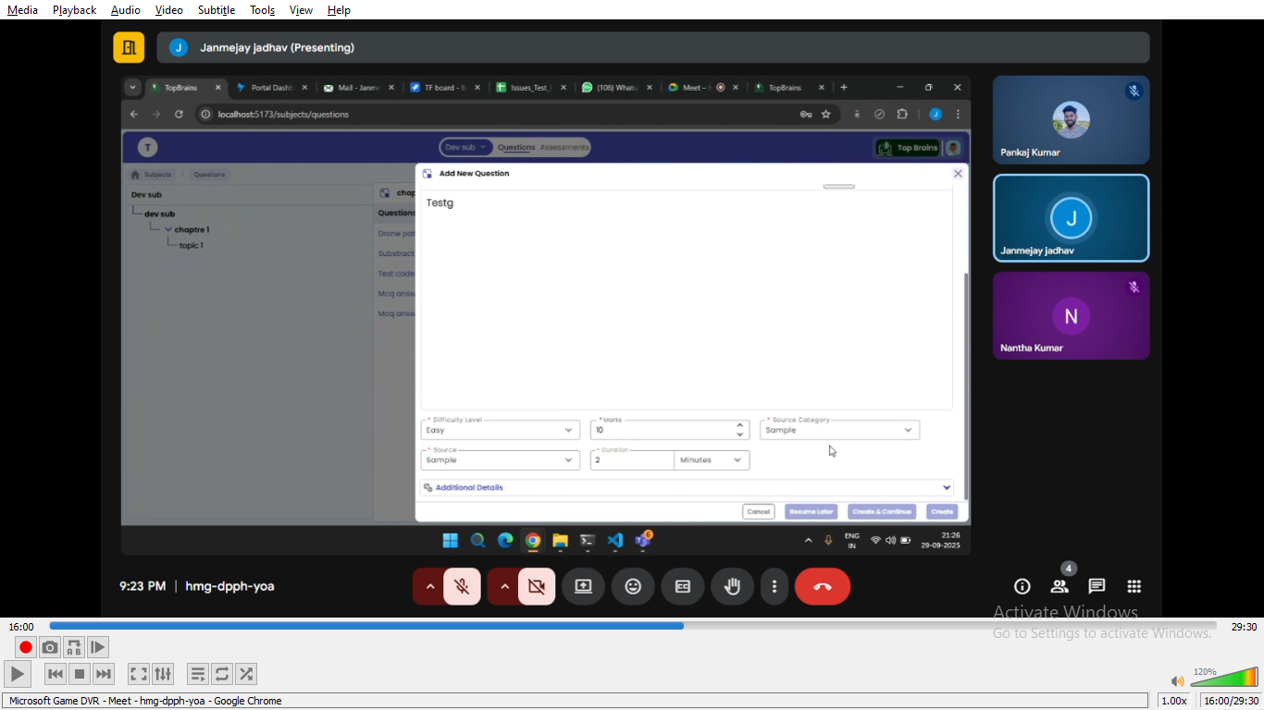

We also have solution details

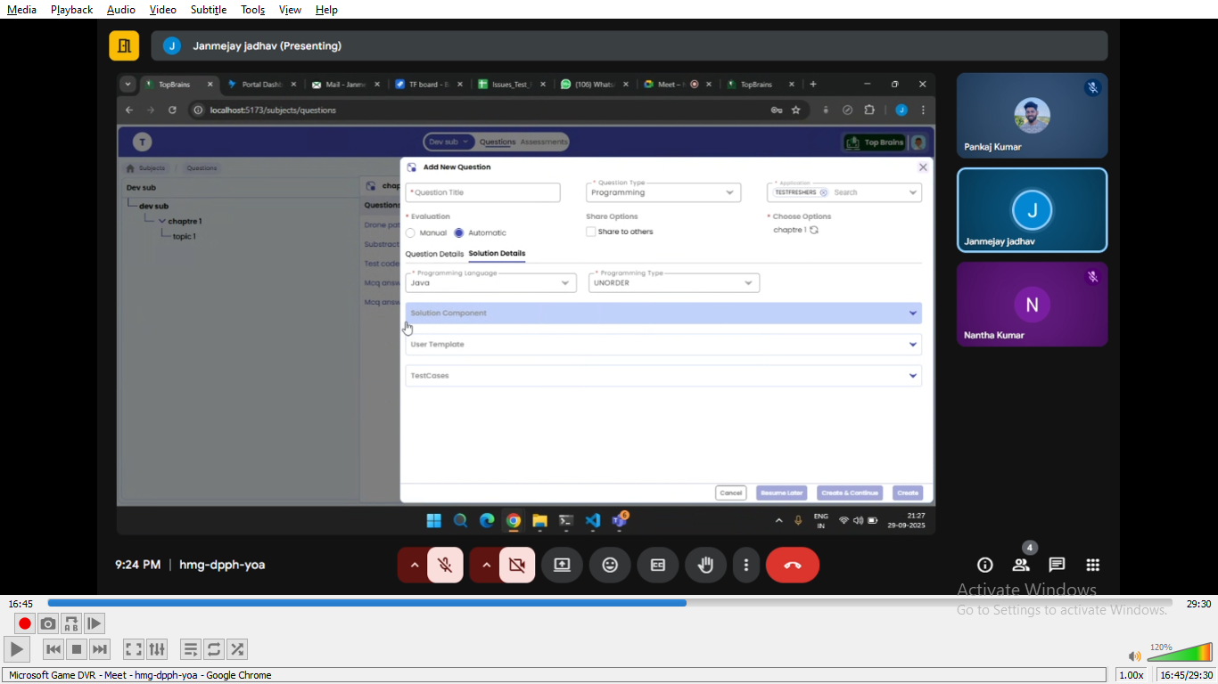

Solution component-how the complete code should be
user template- how the user will get the template for code

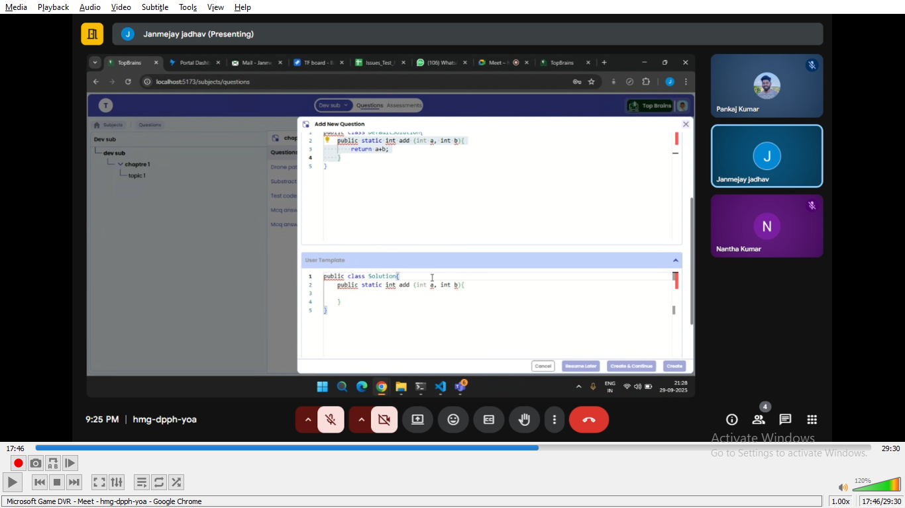
Testcases
We have visibility
And also an icon to run test the case

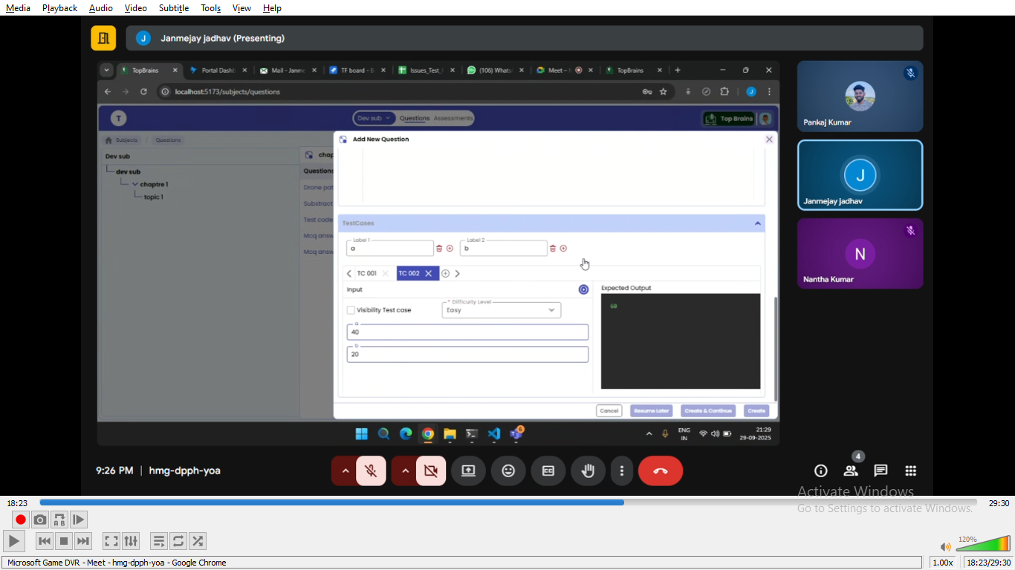

compiler
Backend team hosted in the server-code will send to backend server->compile in server->from there the output is generated
Typing colour->frontend tool-> monoco editor-> based on language colour rendered

After compleation of form->admin will get the following button
- Cancel
- Resume later-the data will saved-and again we can comeback and create the question
- Create & continue-it will create a question but stay in page and we can modify and create a new question
- Create- if admin want to crate only the current question

While clicking on create

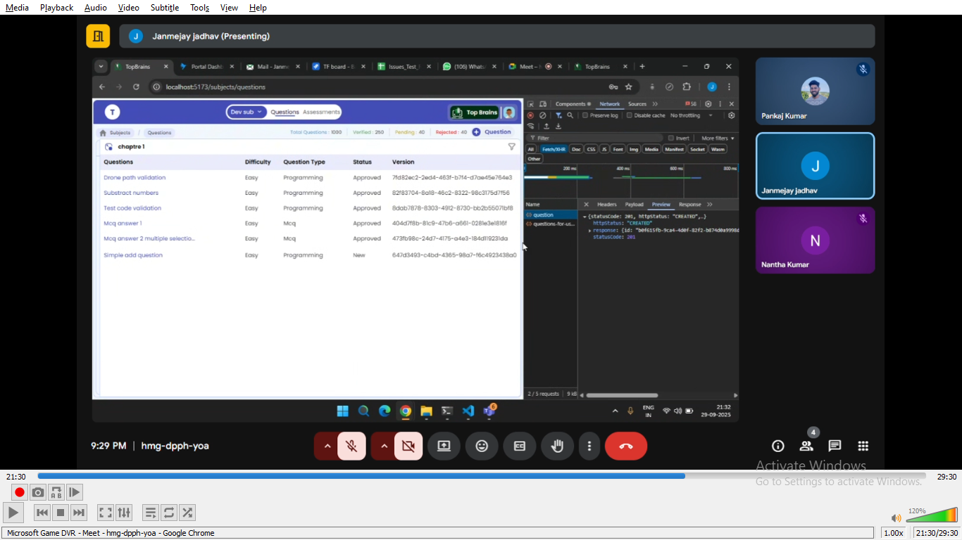
Creation api will be called->console->network->preview (we have the data)
We can also edit the question

Assesement

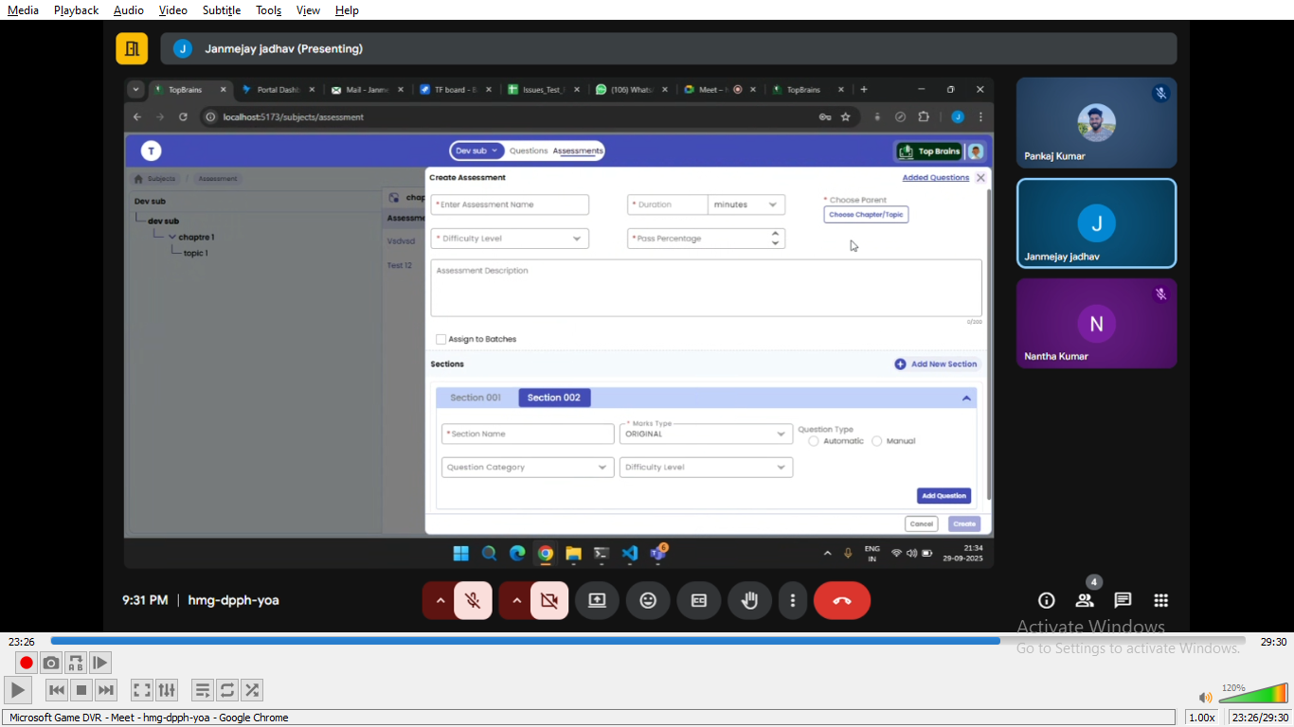

Account->switch role->question verifier

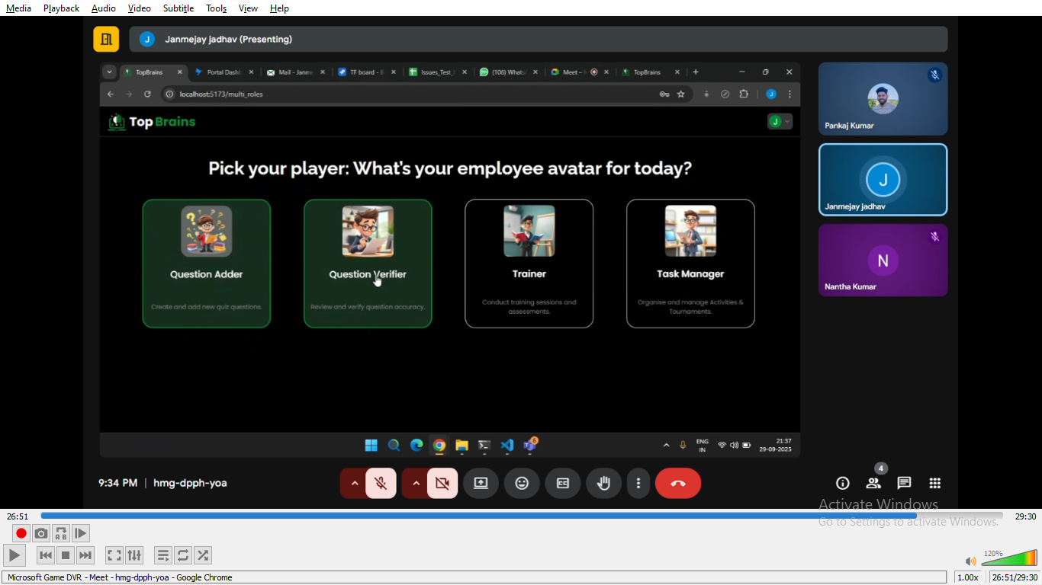
While clicking on the question verifier-> the user navigate to subject page
Click on the subject->
Click on the unapproved question
